Photography debate
Institutional affiliation
Name of lecturer
Name of student
Submission date

Introduction
Photography is the art of taking and producing photographs to represent certain information. A photo acts as a summary of the information being conveyed. Since its inception, photography has become one of the commonly used media of communication in all sectors. The practice has seen great advancement since it was introduced. With technological advancement, the industry has improved tremendously with currently using image sensors, electromagnetic radiations, and photographic films to produce images. Though photography does not give interpretations to information, the practice helps in the documentation of events that enhance the experience of the spectators and the photographer. The practice of photography has experienced numerous debates over the types of photographs that should be taken to represent information. The more heightened discussion was between Aleksandr Shaikhet and Aleksandr Rodchenko in the 1920s and early 1930. The two debate over the use of full photography and fragmented photographs. Aleksandr Shaikhet emphasized the use of full photos, while Aleksandr Rodchenko stresses the use of fragmented images in the representation of information. Their debate attracted many thinkers, and Margarita Tupitsyn summarized the discussion in his article titled 'Fragmentation versus Totality.' Though the two types of photography are important, the use of fragmented images is more crucial than the total pictures. This paper will thus support Aleksandr Rodchenko's point of view that fragmented photography should be encouraged.
Aleksandr Rodchenko represented imagery that was captured a section of the Leningradskoe roller that was used in street paving. His ideas were echoed by Brechtian aesthetics, which claimed that "The spirit of realism designates an active, curious. experimental, subversive ... attitude toward ... the material world; and the 'realistic' work of art is therefore one that encourages and disseminates this attitude, yet not merely in a flat or mimetic way or along the lines of imitation alone.'? The image captured the fine details of the event. As such, fragmented photography captures the fine details of the whole process that the photographer indents to represent. This provides clear information to the spectators and thus reduces cases of misinterpretations. This is because the captured details are precise and no chances of doubts. This is different from the total photography that produces cluttered information as it represented much different information that is not clear to the spectator. The detailed photographs enable the spectators to avoid mistakes in decision making, as the information provided is sufficient and more apparent to them. Rodchenko clearly showed his opposition to press photography by stating "to photograph not a factory but the work itself from the most effective point of view" and that "in order to show the grandness of a machine, one should photograph not all of it but give a series of snapshots."
The reproduction of nature has been a significant challenge that has affected photography over the years. This is a trend found in all full photographs, which makes the lack of originality. Fragmented images avoid such reproductions by capturing the most critical part of the event and thus do not reproduce what is represented by nature. Rodchenko gave an example of an image representing a tree and said the picture should capture only the tree as it is the most important aspect of the photography and not what surrounds it. As such, through fragmentation, every photograph will unique and thus will be appealing to the spectators. Rodchenko's image of roller paving a street was so unique that it did not capture what was represented by nature but what was being done by the roller on the street
Quality of the image is another aspect that is put under consideration when producing a photograph. By focusing on finer details, fragmented images provide high-quality images as compared to total photos. The high-quality images are more appealing to spectators and thus attract more of them. Quality, as such, is something that many photographers take into consideration as it plays a critical role in exposing the important information conveyed. The views and interpreters of the images do not strain to identify what the photographer wanted to communicate as they can locate a different aspect of the image and draw conclusions from it. This makes communication easy and reliable and thus improving photography practices.

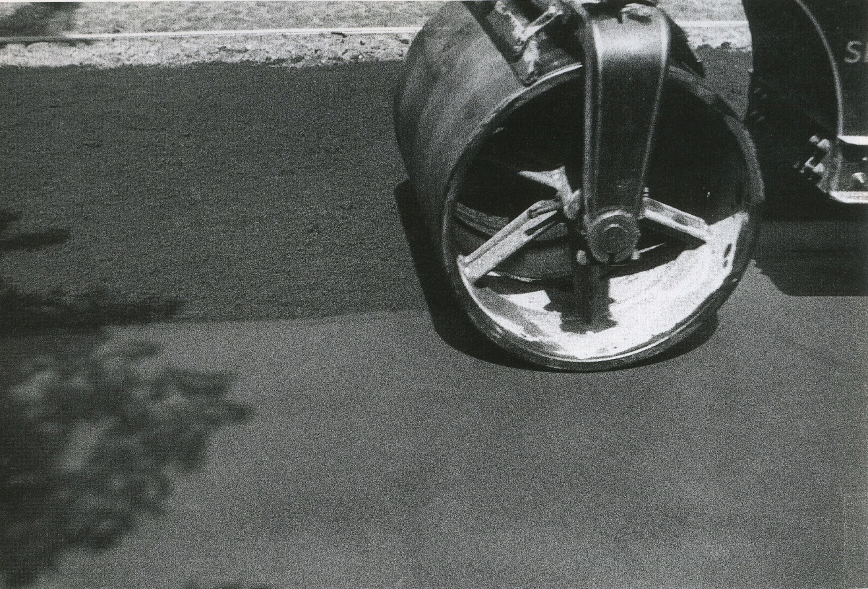

The representation of information on data and information through photography is aimed at representing the social reality of the pace and events that have occurred in the scene. Original images from the scene make the transmission of information more reliable and convenient. It also makes information more acceptable as compared to clattered information. Fragmentation provides such reality scenes and thus is more acceptable as compared to clattered information provided by total images. Comparing the image represented by Rodchenko and that of Shaikhet on street paving, Rodchenko's image was more realistic as compared to Shaikhet. The reality of the event is thus expressed in the fragmented image and therefore makes it acceptable by the spectators.
Many photographers have experienced increased criticism due to taking photographs for the sake of making the photo and not emphasizing the importance and meaning of photography. This is because the photographers mainly focus on capturing the total image that, according to many, does not convey any message, and thus, they lack meaning. Fragmented photos are clear and capture a specific event or an object. This gives photography a meaning and therefore emphasizes the use of photographs is conveying information through visual images. As such, criticisms on the practice of photography will reduce and make it a more acceptable practice in society. Also, through fragmented photography, doubts are eliminated as the information captured is represented. Rodchenko's image well explains this on roller used in street paving.
Conclusion
Photography has become more improved with the use of technology, and thus clearer images and pictures have been painted to convey varied information. Photographers should, therefore, emphasize capture and painting photographs that are represented to eliminate the chance of doubt and criticism. This will improve the sector photography and make it more appealing to both spectators and photographers. As such, my emphasis and request to them are to emphasize of fragmented photographs that will provide adequate information and more clearly to the spectators.

Reference
https://www.homeworkforyou.com/static_media/uploadedfiles/fragmentation_versus_totality.pdf

